Arista Networks (ANET)
Data Infrastructure
U.S.
3/25/2026
Report prepared by:
Alex Pence, Caden Vandygriff, Trevin Elliott
Recommendation: BUY
Current Price (4/2/26): $126.68
Shares Outstanding: 1.26B
Market Capitalization: $159.526B
P/E (TTM): 46.07
Forward P/E: 35.71
Net Debt to EBITDA: -.003
1-Year Target Price: 170.20
3-Year Target Price: 261.82
Annualized 5-Yr Return: 14%

Stock Price Graph (Previous 3 Years)
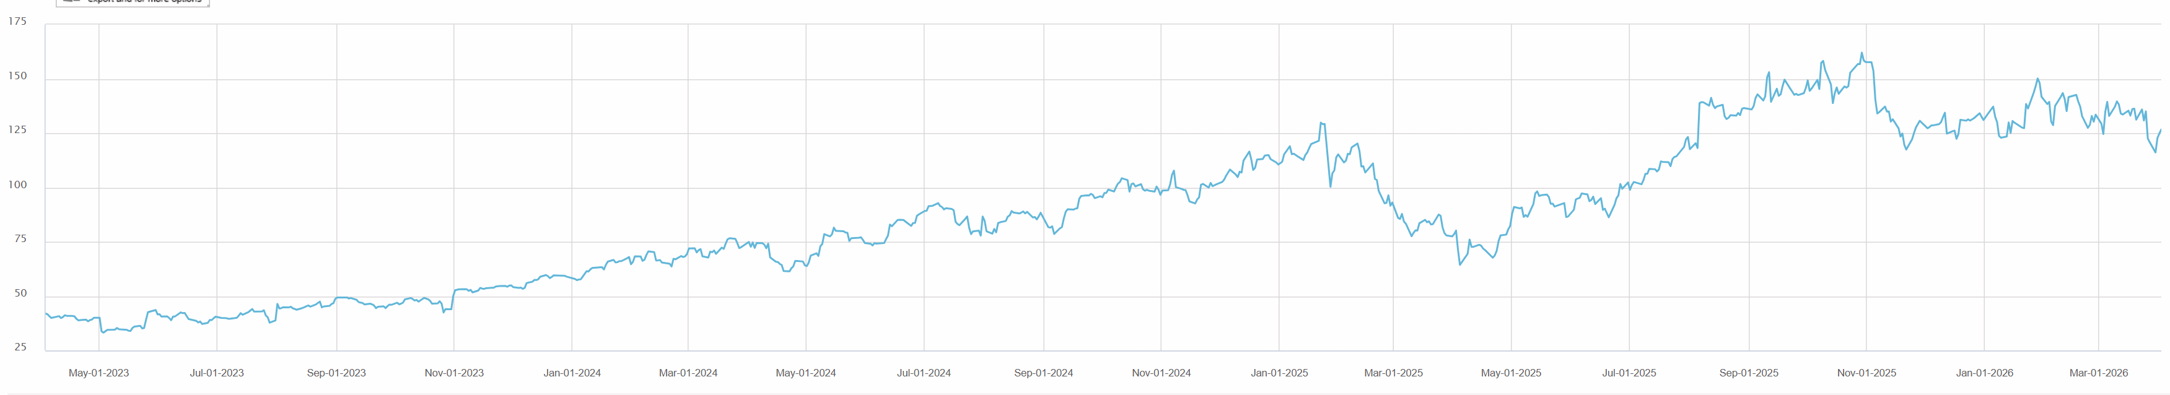
Business Description
Arista Networks (ANET) is a global leader in providing cloud networking solutions. The company primarily operates in the data center and campus networking industry, offering products such as high-performance network switches, routers, and software-defined networking solutions. Arista serves large-scale cloud service providers, enterprise data centers, and financial institutions, focusing on high-bandwidth and scalable architectures. Headquartered in Santa Clara, California, Arista operates through its advanced technology platforms, including its flagship Arista EOS and CloudVision. The company is known for its commitment to improving network performance, reliability, and software-driven agility.
Key Sales Categories
The Company operates exclusively within the Computer Networks reportable segment. Revenue is generated through two primary streams: the sale of high-performance Ethernet switching hardware and recurring maintenance and support services. The percentage revenue coming from the two sales categories are as follows:
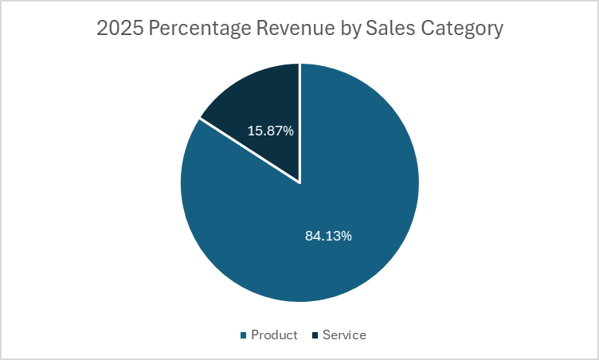

The revenue breakout for the two sales categories over the previous three years are as follows:
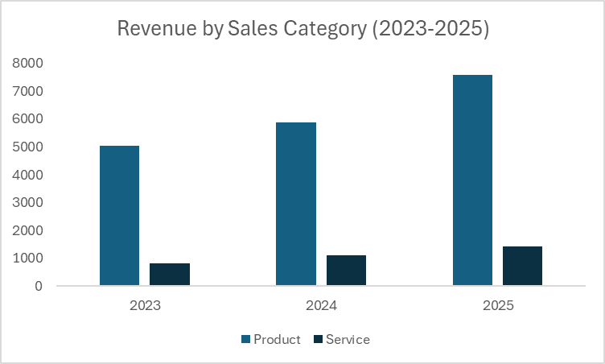

The gross margin breakout for the two sales categories over the previous three years are as follows:
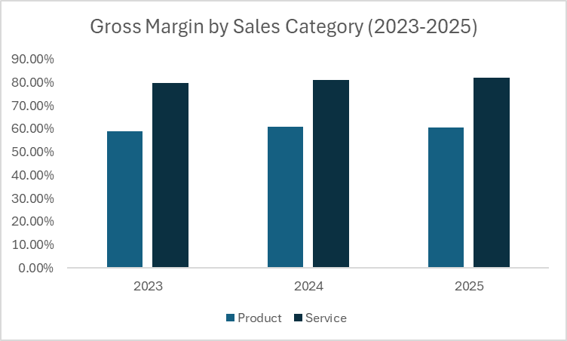
Competitive Market
Arista Networks operates in a highly competitive networking market, facing strong competitors such as Cisco, Juniper, and Hewlett Packard Enterprise. These competitors offer broad networking solutions, often with a heavier focus on legacy enterprise hardware. In contrast, Arista differentiates itself by providing high-performance, software-driven cloud networking solutions that emphasize programmability, low latency, and scalability, while still maintaining a competitive portfolio of data center and enterprise networking products.
Arista’s Strategy
Arista Networks’ strategy focuses on delivering high-performance, programmable networking solutions through continuous innovation and operational excellence. The company emphasizes software-driven approaches, expanding its cloud networking portfolio, and enhancing its direct relationships with enterprise and cloud customers to drive growth, maintain competitive differentiation, and ensure customer satisfaction.
Industry Analysis (Porter’s Five Forces)
Threat of New Entrants (Low): The networking industry presents high barriers to entry for several reasons. First, developing high-performance, cloud-scale networking hardware and software requires substantial capital investment in R&D, manufacturing, and engineering talent. Second, Arista benefits from strong brand recognition and a reputation for innovation in data centers and cloud networking. Third, networking products must meet rigorous performance, reliability, and compliance standards. Finally, Arista’s deep relationships with enterprise and cloud customers create a loyal customer base that is difficult for new entrants to penetrate.
Bargaining Power of Suppliers (Moderate): Arista Networks relies on specialized components, such as high-performance silicon chips, optics, and networking hardware, which are sourced from a limited pool of suppliers. Global supply chain constraints, including semiconductor shortages, can increase supplier leverage. However, Arista mitigates this risk through strategic partnerships, long-term supply agreements, and by designing its own software-driven platforms that maximize flexibility across different hardware components.
Bargaining Power of Buyers (Moderate to High): Arista Networks’ buyers can be grouped into two primary categories: (1) large cloud providers and (2) enterprise customers. Cloud providers purchase at significant scale, are highly sophisticated, and often negotiate aggressively on price and performance, giving them substantial bargaining power. Enterprise customers, while typically purchasing in smaller volumes, are still well-informed and can compare solutions across multiple vendors.
However, Arista mitigates buyer power through its differentiated, software-driven networking solutions, which offer high performance, scalability, and programmability. These features create switching costs and reduce price sensitivity, particularly for customers that rely on Arista’s platforms for mission-critical data center and cloud operations.
Threat of Substitutes (Low): Networking infrastructure is essential for modern data centers, cloud computing, and enterprise operations, leaving few direct substitutes for Arista Networks’ core offerings. While alternative approaches such as software-defined networking overlays or white-box hardware solutions exist, these options often still rely on high-performance switching and routing infrastructure. The primary threat comes from technological innovation that could shift how networks are built and managed; however, Arista has consistently been a leader in innovation, particularly with its software-driven and cloud-focused networking solutions, helping it stay ahead of potential substitutes.
Industry Rivalry (Moderate): Arista Networks operates in a highly competitive industry, facing key competitors such as Cisco, Juniper Networks, and Hewlett Packard Enterprise. These companies offer similar networking solutions and serve many of the same enterprise and cloud customers, leading to intense competition on pricing, performance, and service. Additionally, there is significant pressure to innovate, as advancements in speed, scalability, and software capabilities are critical factors that differentiate competitors in the networking market.

Theses
Strong moat driven by high switching costs: Arista Networks operates in the high-performance networking segment, where customers depend on reliable, scalable, and software-driven infrastructure. Switching to a competitor is not just a matter of changing hardware; it requires retraining staff, reconfiguring network architecture, and ensuring software and operational compatibility. This creates substantial switching costs that protect Arista’s customer base and give the company a durable competitive moat. Large cloud providers and enterprises that integrate Arista’s solutions deeply into their data centers are especially locked in, as disruption could negatively impact performance and uptime.
Moreover, Arista’s focus on software-driven networking, including programmability and automation, increases customer reliance on its platform. Features like Arista EOS (Extensible Operating System) integrate across devices and provide advanced monitoring, analytics, and orchestration capabilities. These capabilities make it costly and complex for customers to transition to other vendors, further reinforcing Arista’s competitive advantage. The combination of high-performance hardware and tightly integrated software ensures that customers remain committed, allowing Arista to maintain premium pricing and stable long-term relationships.
ANET competes at the high end of networking, where reliability, software, and scale matter more than price: Arista Networks differentiates itself by targeting the high-end networking market, where customers prioritize performance, reliability, and scalability over cost. This focus allows the company to deliver solutions optimized for cloud data centers, large enterprises, and high-frequency trading environments, where downtime or latency can result in significant financial and operational losses. By emphasizing quality, low latency, and software programmability, Arista positions itself as a premium provider that meets the most demanding customer needs.
This high-end positioning also shields Arista from the pressures of commoditized price competition that lower-tier vendors face. Customers in this segment are willing to pay a premium for reliability, seamless integration, and advanced software features. By continuously innovating in areas such as network automation, AI-driven monitoring, and high-throughput hardware, Arista strengthens its reputation as a leader in enterprise and cloud networking, attracting customers who value performance and long-term reliability over cost savings.

Exceptional Financial Performance and Operational Efficiency: Arista Networks has demonstrated strong financial performance, consistently delivering revenue growth, healthy margins, and solid free cash flow. Its focus on operational efficiency, driven by a software-centric model and scalable hardware design, allows the company to achieve higher margins than many competitors in the networking space. This financial strength provides Arista with flexibility to invest in R&D, pursue strategic acquisitions, and expand into new markets without compromising profitability.
Additionally, Arista’s operational model emphasizes streamlined product development and supply chain management, enabling the company to respond quickly to market demand while maintaining cost discipline. Its ability to scale efficiently, combined with recurring revenue from software subscriptions and support contracts, enhances predictability and reduces risk. This operational and financial discipline not only reinforces investor confidence but also ensures that Arista can sustain long-term growth in a highly competitive industry.
Valuation
We used a blended valuation approach using both a discounted cash flow (DCF) analysis and comparable company analysis to derive a fair value for Arista Networks. We will break down our assumptions for both valuations below. Our intention is to quantify our thesis points above by integrating assumptions into our model. Our primary assumptions will be related to revenue growth, margin expansion, risk, and peer performance. We believe that our assumptions are fair and reasonable. Our assumptions are in line with other BUY rated coverage by other analysts.
Discounted Cash Flow Analysis
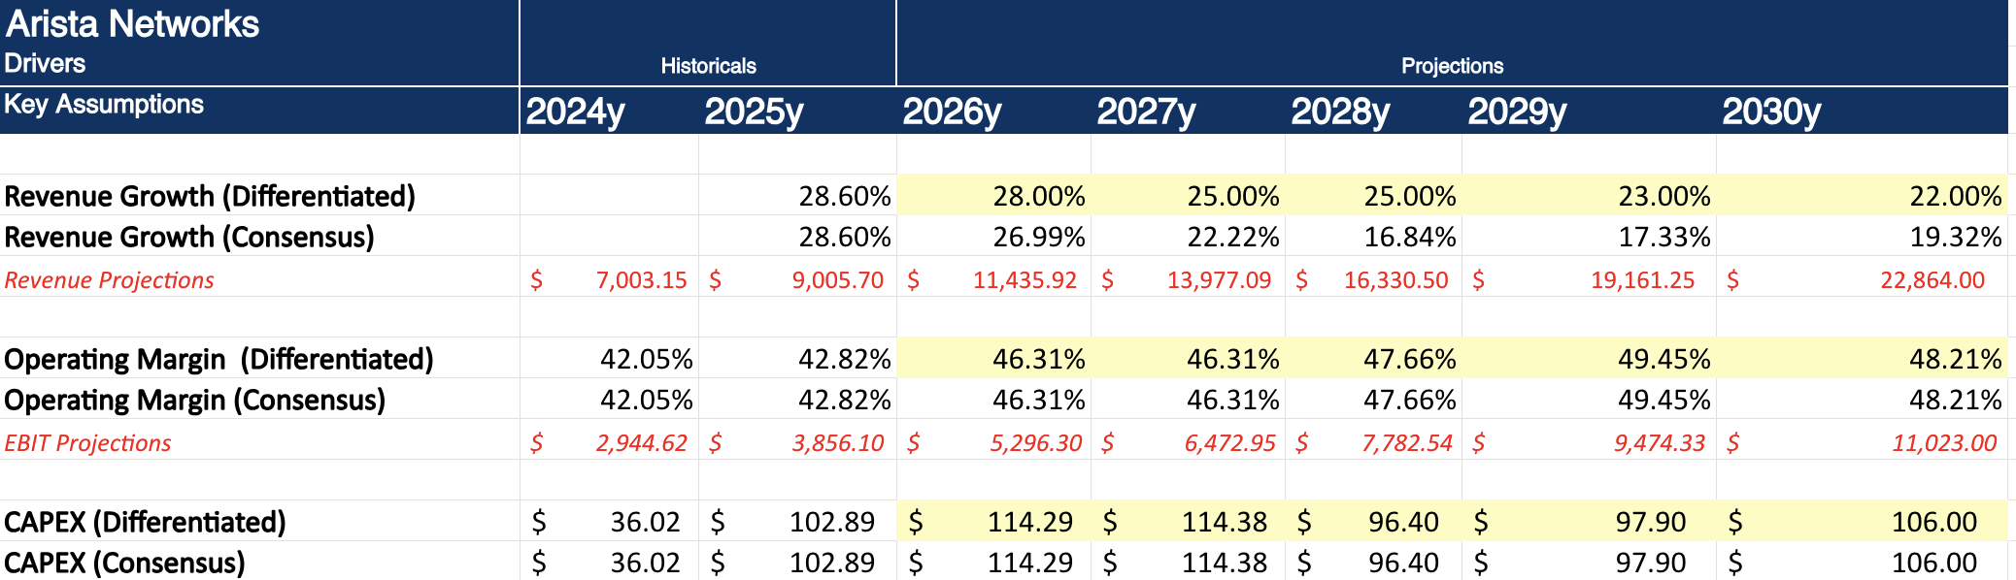
Our valuation of Arista Networks is supported by both a DCF framework and a stronger emphasis on market-based multiples. While the DCF helps capture the company’s long-term earnings power through forecasted free cash flows, we place greater weight on relative valuation given the fast-moving nature of AI infrastructure and networking demand. We assume a higher revenue growth trajectory than consensus, supported by our thesis that Arista continues to benefit from sustained AI-driven data center investment and share gains in high-performance Ethernet. We also model modest margin expansion over time, reflecting operating leverage and a product mix shift toward higher-value AI networking solutions, with margins trending toward top-tier peer levels.

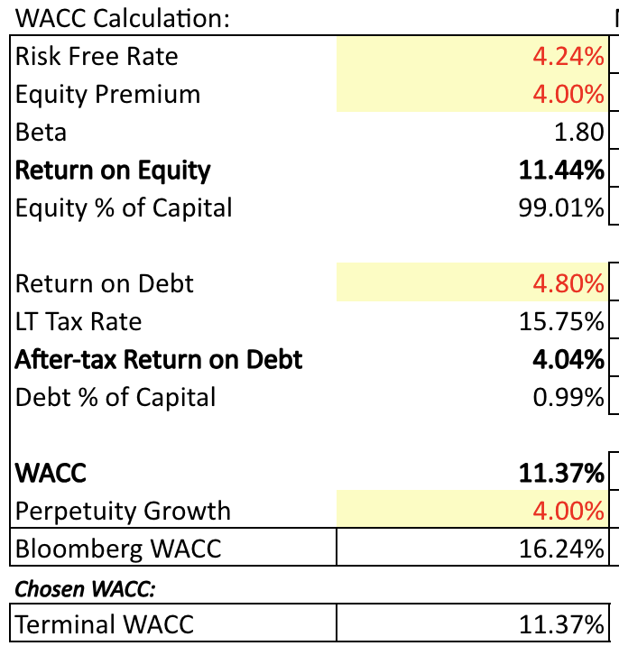
After determining our free cash flow based on our differentiated drivers, we discounted these free cash flows in the discrete and terminal period. This resulted in an equity value of approx. 171 billion. As can be seen in our figure above, we discounted these cash flows using the rate of 11.37%. We calculated this rate using a weighted average cost of capital methodology. Most of our differentiation comes from a lower WACC. Arista Networks should command a lower WACC given its strong balance sheet, high margins, and predictable cash flow profile. The company has little to no debt, which reduces financial risk, and consistently generates high returns on capital with strong free cash flow conversion.
Comparable Company Analysis
To supplement our DCF, we conducted a peer benchmarking valuation using a selection of publicly traded Ethernet/High Speed Switching companies with similar business models and products. Key valuation multiples considered included revenue, EBITDA, EBIT, UFCF, and P/E.
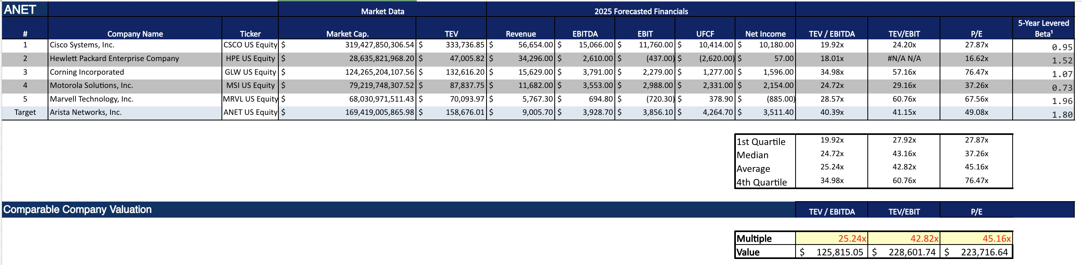
This comparable company analysis reinforces our view that Arista trades at a premium for a reason, but not an unjustified one. Relative to peers, ANET screens above the group on TEV/EBITDA, TEV/EBIT, and P/E, which reflects its superior growth profile, higher margins, and strong positioning in AI-driven networking. While the peer average implies a lower valuation range, we think applying median or average multiples understates Arista’s quality. Importantly, on a forward PEG basis, Arista looks more reasonable, at roughly ~1.8x compared to Cisco at ~2.8x and Nvidia around ~2.3x, suggesting its valuation is better supported by its expected growth. This indicates the premium is driven more by fundamentals than multiple expansion alone. Given its consistent execution, operating leverage, and exposure to hyperscale and AI infrastructure spend, we believe ANET deserves to trade toward the high end of the comp range, supporting our decision to lean more heavily on multiples while using the DCF as a directional check.
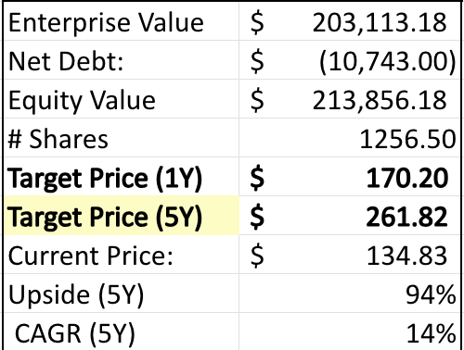Target Price
Taking the average of our DCF and market multiples valuations, we arrive at a fair value estimate of $261.82 per share, representing a 14% CAGR over the next 5 years. We believe this supports our buy recommendation and supports our claim that ANET, while valued at a premium, still has a lot of room to grow.

Risks & Challenges
We have identified five main risks for Arista Networks which we will discuss in more detail below: (1) customer concentration risk, (2) macroeconomic and enterprise spending sensitivity, (3) competitive pressure and pricing risk, (4) supply chain and component dependency, and (5) technological disruption and innovation risk.
Customer Concentration Risk: Arista derives a significant portion of its revenue from a small number of large cloud customers, including hyperscalers such as Microsoft and Meta Platforms. While these relationships drive strong growth, they also create risk, as any slowdown in spending, shift in vendor preference, or internal development of networking solutions could materially impact Arista’s revenue. Large customers also have significant bargaining power, which can lead to pricing pressure or reduced margins over time.
Additionally, purchasing patterns from hyperscalers tend to be lumpy and cyclical, leading to potential volatility in quarterly results. A pause or delay in data center expansion by even one major customer could have an outsized effect on Arista’s financial performance, making revenue less predictable compared to more diversified competitors.
Macroeconomic and Enterprise Spending Sensitivity: Arista’s growth is closely tied to capital expenditures from cloud providers and enterprise IT budgets. During periods of economic uncertainty, companies often delay or reduce spending on data center infrastructure and networking upgrades. Higher interest rates, inflation, or a slowdown in global economic activity could dampen demand for Arista’s products, particularly among enterprise customers.
While cloud demand has historically been resilient, it is not immune to macroeconomic cycles. A slowdown in cloud spending or optimization efforts by large customers could lead to reduced growth rates. Because Arista operates in a high-performance segment, where deployments are often large and strategic, delays in customer investment decisions can significantly impact near-term results.
Competitive Pressure and Pricing Risk: The networking industry is highly competitive, with major players such as Cisco Systems, Juniper Networks, and Hewlett Packard Enterprise continually investing in innovation. These competitors offer similar products and aggressively compete on pricing, performance, and bundled solutions. As a result, Arista faces ongoing pressure to maintain its technological edge while managing pricing dynamics.
Arista’s premium positioning, while a strength, could become a vulnerability if customers prioritize cost over performance during economic downturns. Additionally, competitors are increasingly investing in software-defined networking and AI-driven infrastructure, which could narrow Arista’s differentiation over time if it fails to keep pace with innovation.
Supply Chain and Component Dependency: Arista relies on a global supply chain for critical components such as semiconductors, switching silicon, and optical modules. Disruptions caused by geopolitical tensions, trade restrictions, or semiconductor shortages could lead to increased costs, delayed production, or inability to meet customer demand.
Although Arista has taken steps to diversify suppliers and improve supply chain resilience, it remains exposed to external risks beyond its control. Prolonged disruptions could compress margins or impact customer relationships if delivery timelines are not met, particularly given the mission-critical nature of its products.
Technological Disruption and Innovation Risk: The networking industry evolves rapidly, and Arista must continuously innovate to maintain its leadership position. Emerging technologies such as AI-driven networking, custom silicon developed by hyperscalers, and alternative architectures like white-box switching could disrupt traditional networking models. If customers increasingly adopt in-house solutions or alternative platforms, Arista’s growth could be affected.
Furthermore, maintaining leadership in software-driven networking requires sustained investment in R&D. Any failure to anticipate or respond to major technological shifts, such as changes in cloud architecture or network design, could erode Arista’s competitive advantage and reduce its relevance in the long term.

Appendix:
Bloomberg Reports
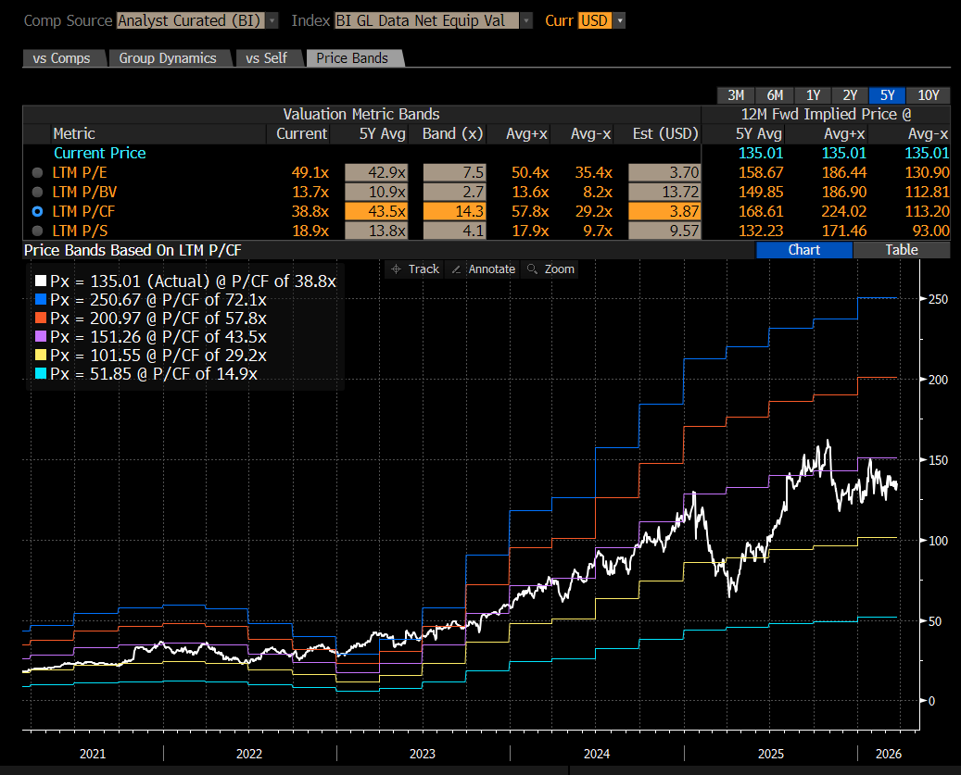
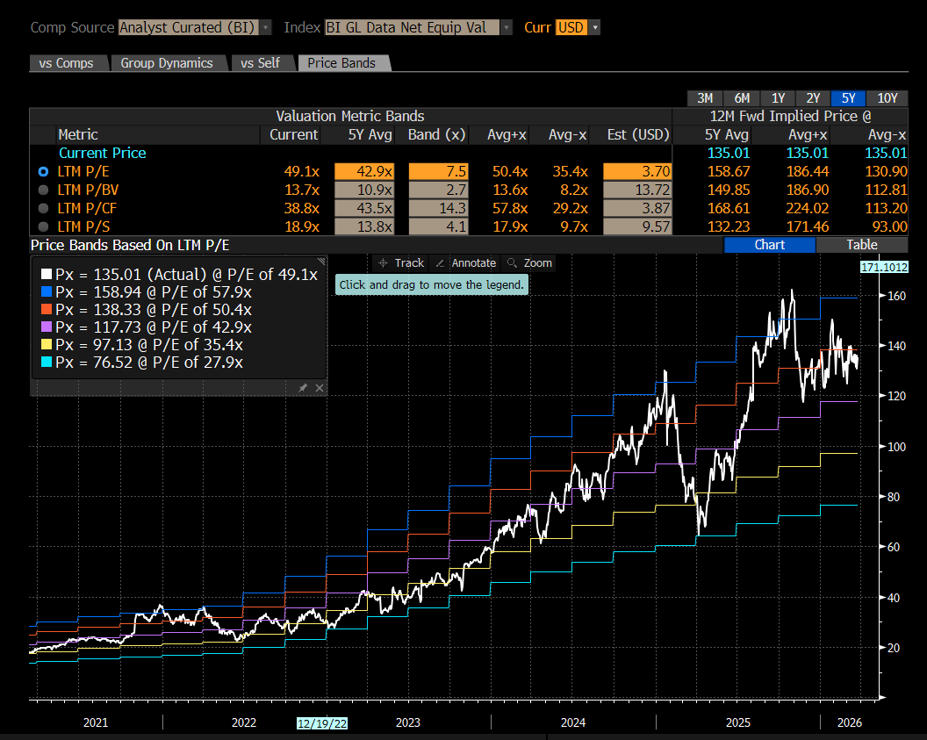
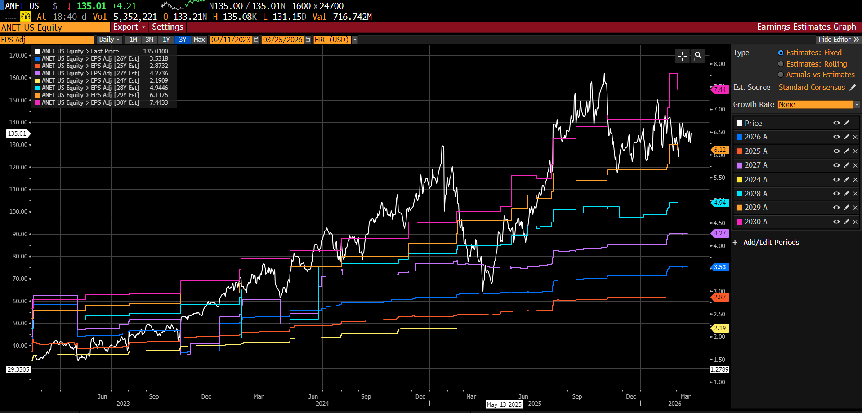
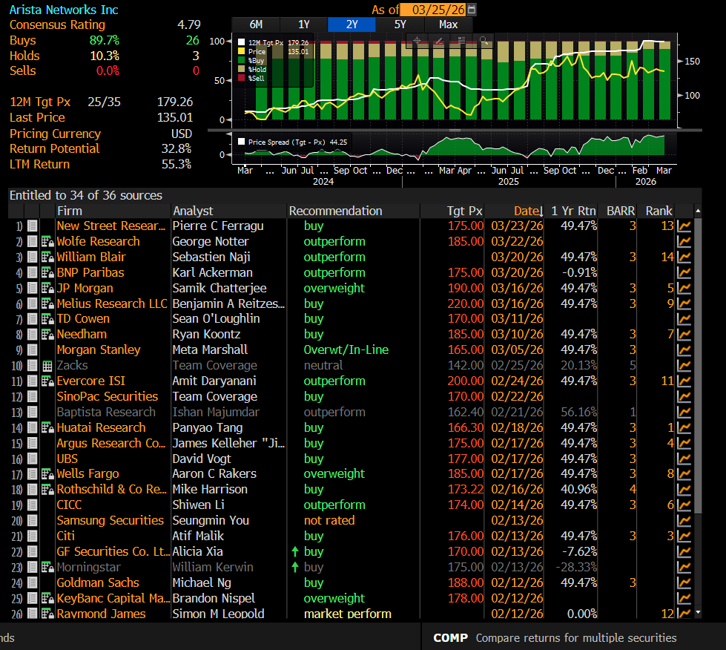

Financial Statements (2025 FY)
